SAFETY BAY SENIOR HIGH SCHOOL

STAGE 2 HUMAN BIOLOGICAL SCIENCES

DIGESTIVE AND EXCRETORY SYSTEM TEST

Total Marks = 50 Marks
Section A: Multiple Choice (15 Marks)

1. When proteins have been completely digested and are ready for
absorption they are in the form of:
(a) glucose
(b) fatty acids
(c) amino acids
(d) glycerol

2. Food is moved through the alimentary canal by muscular action known as:
(a) metabolism
(b) peristalsis
(c) elimination
(d) defecation

For questions 3 and 4, refer to the graph below showing the activity of two different enzymes found in the human digestive tract;

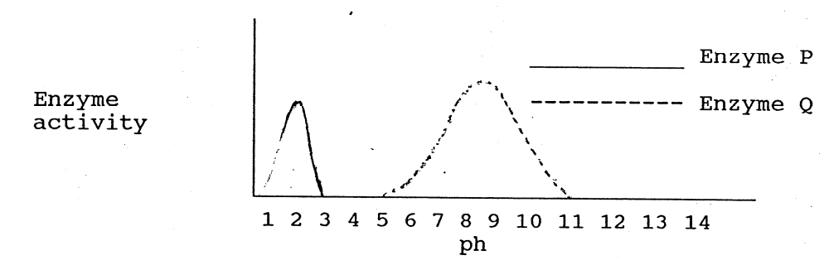
3. Enzyme P is most likely to be:
- an amylase
- a lipase
- a protease
(d) it is impossible to say
4. Which of the following statements about P and Q is true?
(a) Enzyme P is most active in an acidic medium and enzyme Q is most active in an alkaline medium
(b) Enzyme Q will only be activated in one part of the digestive tract however enzyme P will be active all along the digestive tract
(c) Enzyme Q will only break down carbohydrate however enzyme P will break down carbohydrate, protein and lipids
(d) Enzyme P will be active over a wider pH range than enzyme Q

5. Hydrochloric acid in the stomach:
(a) is a symptom of a digestive disorder
(b) is a digestive enzyme which hydrolyses fat
(c) assists in the digestion of starch
(d) contributes to the chemical digestion of protein

6. The teeth used for biting and cutting of food are:
(a) molars and premolars
(b) molars and canines
(c) incisors
(d) canines

7. The part of the digestive tract where absorption of water and vitamins occurs is the:
(a) large intestine
(b) small intestine
(c) stomach
(d) pancreas

8. Chemical digestion of carbohydrates:
(a) begins in the stomach and continues until the large intestine
(b) occurs at all points along the digestive tract
(c) takes place mainly in the large intestine
(d) begins in the mouth

9. Approximately 1.5L of urine is passed each day by a healthy person. Which of the following could be cause for concern in regards to urine passed?
(a) the urine is around 99% water
(b) the urine contains glucose
(c) the urine has a pale yellow colour
(d) the urine does not contain significant amounts of protein

10. The correct order of the major processes occurring in the kidneys is:
(a) glomerular filtration, reabsorption, tubular secretion
(b) reabsorption, tubular secretion, glomerular filtration
(c) tubular secretion, reabsorption, glomerular filtration
(d) glomerular filtration, tubular secretion, reabsorption

11. Which of the following organs are NOT involved in excretion of wastes?
(a) lungs
(b) stomach
(c) kidneys
(d) sweat glands in the skin

12. In order to help maintain healthy kidneys it is advised that certain lifestyle habits are avoided. Which of the following is NOT a habit that should be avoided in this case?
(a) smoking
(b) excessive alcohol consumption
(c) being overweight
(d) drinking water rather than drinks containing sugar

13. The kidneys remove nitrogenous wastes from the body. Choose the correct list of these wastes:
(a) water, urea and bile
(b) urea, uric acid and creatinine
(c) uric acid, urea and salt
(d) urea, creatinine and salt

14. Measures such as protective clothing, gloves and surgical masks help reduce the risk of infections by:
(a) sterilising the surrounding air
(b) providing an alternative pathway for invading pathogens
(c) providing a mechanical barrier that acts as an obstacle to invading pathogens
(d) signalling to others that the protected person may be carrying a disease

15. Topical preparations to prevent or treat infections are those which are applied:
(a) orally
(b) to surfaces around the home such as kitchen benches
(c) to relieve pain
(d) the skin

Section B – Short Answer Section (25 Marks)

1(a) What is the name of the structure shown in the diagram below? __________ (1)

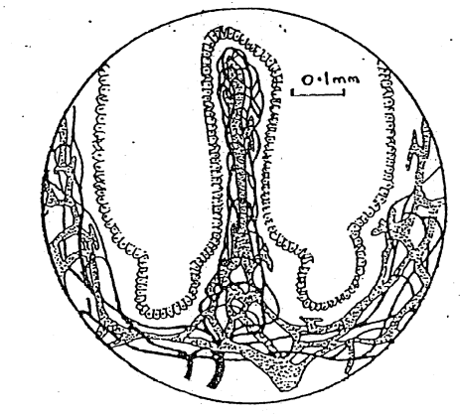

(b) What is the main function of this structure? __________________________
_____________________________________________________________________________________________________________________________ (2)

(c) Give two ways that this structure is suited to its function?

(i)___________________________________________________________________________________________________________________________ (1)
(ii) _____________________________________________________________________________________________________________________________ (1)
2. Label the following diagram of the kidney (3) 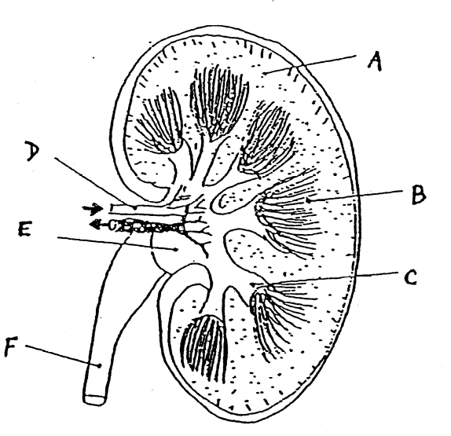
3. Urea is a toxic waste product that is produced by normal processes in the human body.

(a) Explain how urea comes to be present in the body ________________________
_____________________________________________________________________________________________________________________________________________________________________________________________________________________________________________________________________________________________________________________________________________________________________________________________(2)

(b) How is urea removed from the body? _________________________________
_____________________________________________________________________________________________________________________________________________________________________________________________________________________________________________________________________________________________________________________________________________________________________________________________(2)

4. Label the following diagram of the digestive system (1/2 each = 4)

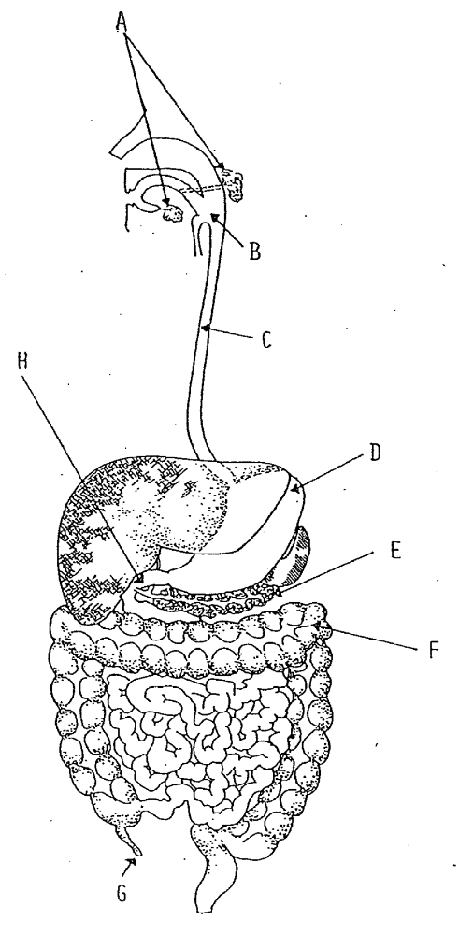

5. (a) Give three examples of a large surface area in the kidneys
and for each example; (3)
(b) State how this assists in the excretion of waste and regulation of water content in the body. (6)
 | (a) examples of large surface area | (b) how this assists with excretion and/or regulation
(i)
(ii)
(iii)
Section C – Extended Answer Section (10 Marks)

For breakfast you have a fried egg. Discuss the fate of your breakfast from the time it enters your body until it is absorbed or eliminated from your body.
In your discussion you should mention;

(a) The food nutrient groups present. (1 mark)

(b) The regions of the alimentary canal it passes through and their functions. (4 marks)

(c) The digestive enzymes involved and what they act upon. (4 marks)

(d) The final products. (1 mark)

